

**Computer Games Technology**

A JavaScript Runtime for Hardware Accelerated Applications

**Computing Honours Project (COMP10034)**

**Project Management Report**

William Taylor

**B00235610**

24/03/2017

**Supervisor: Paul Keir**

Table of Contents

1.0 Management Overview 3

1.1 Gantt Charts 3

1.2 Version Control 4

1.3 Statistics 5

2.0 Supervisor Meetings 7

2.1 Meeting 1 7

2.2 Meeting 2 9

2.3 Meeting 3 11

2.4 Meeting 4 13

2.5 Meeting 5 15

2.6 Meeting 6 17

2.7 Meeting 7 19

2.8 Meeting 8 21

2.9 Meeting 9 23

3.0 Conclusion 25

# 1.0 Management Overview

A great deal of consideration went into managing the work in this module as there was a lot to do. To ensure a smooth head start to the work a lot of research was undertaken before the start of the module to assess the feasibility of the project. This ensured that the Software Development and the Interim Report could be finished in trimester one and allowed plenty of time to spend on the final honours report and presentation in trimester two without worrying about additional development work. Additionally, I arranged my supervisor early prior to coming back from a work placement to get immediate feedback on the project’s concept and overarching objectives.

Meetings were held on a fortnightly basis and there were several informal meetings as well which took place in the later stages of each trimester. Agendas and minutes taken during these meeting is part of this document. This allowed me to get immediate feedback on progress to ensure I stayed on track and to ensure I could tap into the advice available through my supervisor and moderator.

## 1.1 Gantt Charts

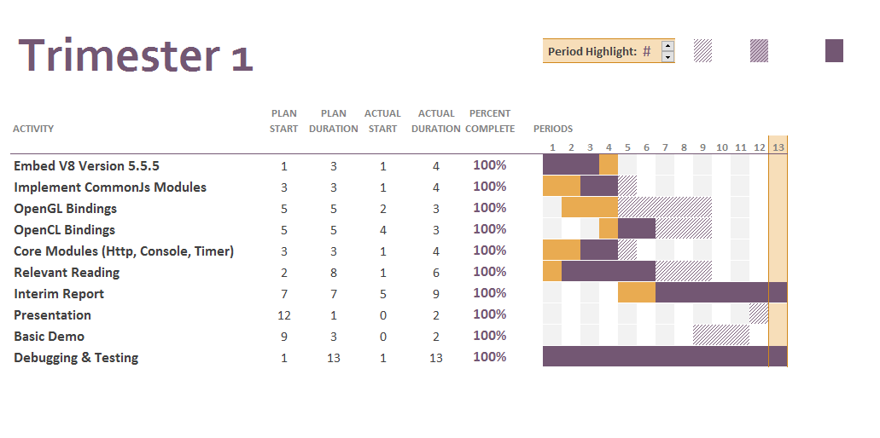To help layout the tasks and work to be done in both trimesters a Gantt chart was created for each trimester. I am very fortunate to have followed these Gantt charts to the letter resulting in a project that was completed earlier than expected. When it came to creating the Gantt charts a single task was broken down into sub tasks and then put as a task in the Gantt Chart. Particularly in trimester one you can see a lot of tasks were finished earlier than expected and that was thanks to a lot of development work being done before the module started. There wasn’t any trouble with the development and the construction of the report. The timescales set were largely followed with relative ease and having the Gantt charts did help allocate work and track my progress. 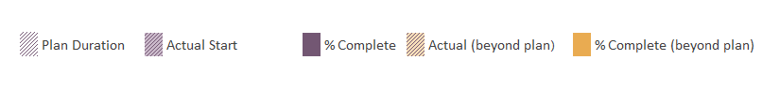

## 1.2 Version Control

As this was a development based project rather than a normal research based project Git was used for version control to ensure there was good management of the source code. In fact, this was used from day one of the project. This not only allowed me to manage code more easily but it allows easier troubleshooting and risk management as errors can be tied to an individual commit allowing bugs to be easily found and removed.

Using Git for version control was only one side of the coin. The entire application’s source code as well as documents such as the reports were hosted on GitHub an online git hosting system. GitHub is a fantastic tool and provides many features including the easy tracking of issues through issue management and release control through its release functionality. It also gives a great graphical representation of the repository’s progress and workflow state through several graphs that can be viewed online anywhere. Below you can find a link to the repository online which is public to anyone who wishes to browse the source code. The graphs you see later in this report are from GitHub which generates graphs and statistics for the repository without any commands need. Also, if people wanted to add to the this honours project they could. They could fork the repository and make they own additions to the platform.

***Online Repository Link:*** <https://github.com/wt-student-projects/computing-honours-project>

## 1.3 Statistics

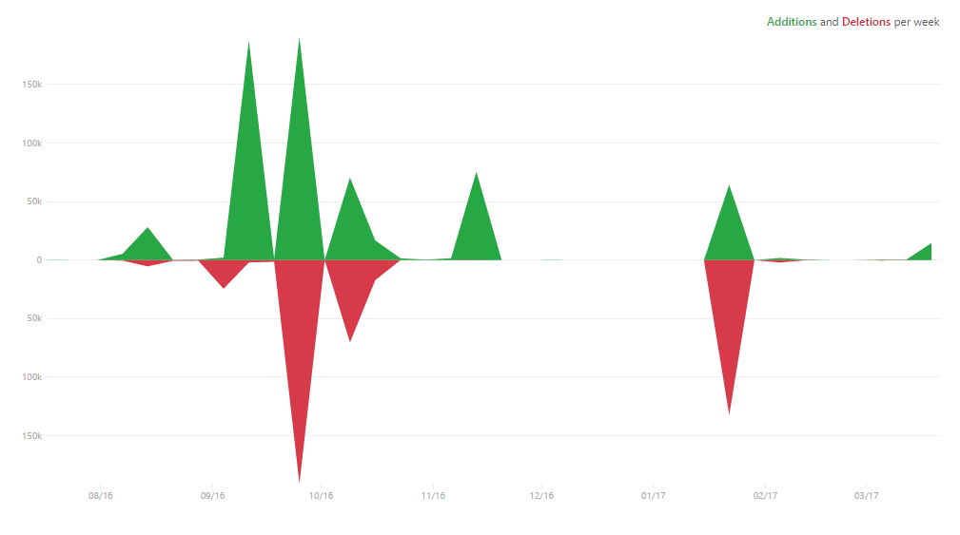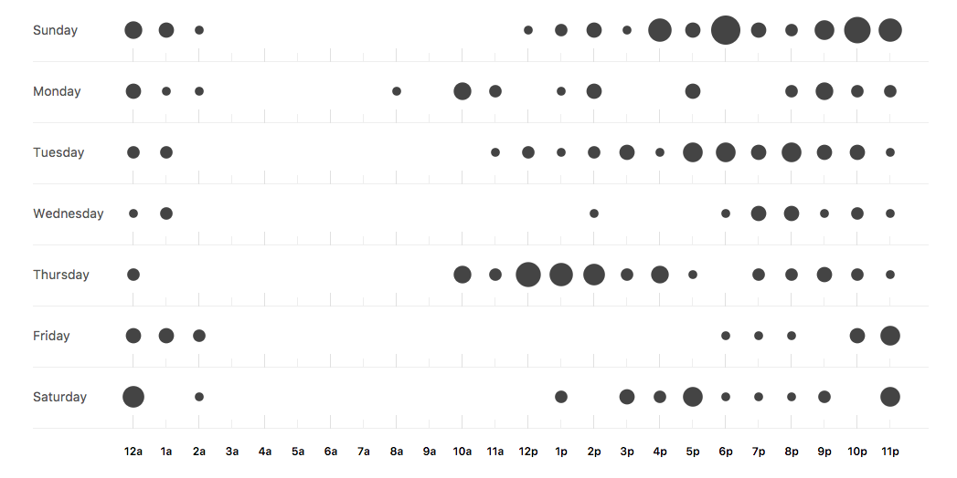These statistics cover my time from when I started the repository and when I handed in my final draft to my supervisor. As is seen I did spend a lot of work on this project and you can see that there are spikes on the contribution graph that relay with the hand in dates for various submissions. You can also see the punch card which breaks down what days I did my work. It is also worth noting that the repository didn’t just house the code for the platform. It contained all documents for the project including the final honours report, project meetings etc. So, the statistics given is for the entire project not just the source code which is why contributions, additions and deletions are so high.

Punch chart showing commits spread across time and day

Additions and deletions

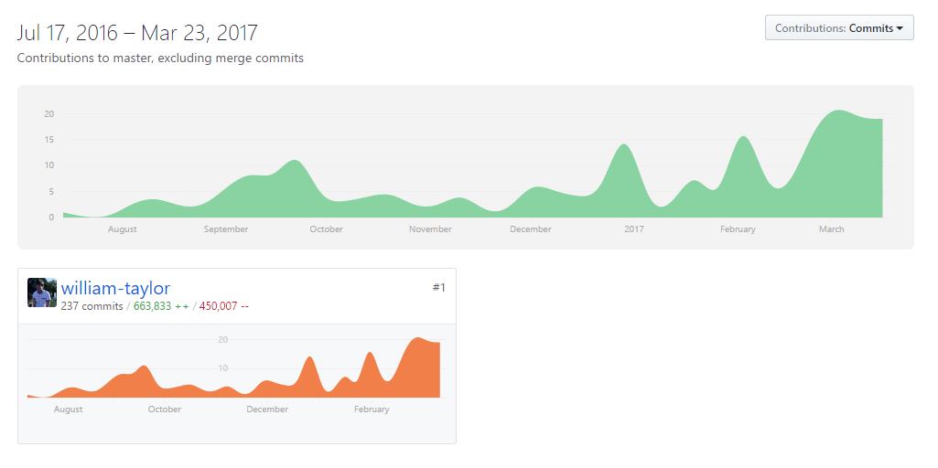

Contributions for the module

# 2.0 Supervisor Meetings

## 2.1 Meeting 1

**COMPUTING HONOURS PROJECT (COMP10034)**

**PROGRESS AND MANAGEMENT MEETING AGENDA**

**Student:** William Taylor **Supervisor:** Paul Keir

**Meeting Number:** 1  **Date/Time:** 12:00 19/09/2016

**PROGRESS**

The following progress has been made and will be discussed with the supervisor.

* Submitted draft project specification.
* Bought a book OpenGL which covers the latest standard.
* Also, bought a book on OpenCL which covers the latest standard.
* Acquired new hardware for my home PC for better testing of the platform.
* Got a HelloWorld demonstration to show off the concept and initial idea.
* Made improvements to my project specification after initial consultation.

**AGENDA FOR FORMAL MEETING**

This is the structure for the formal meeting. This meeting should be fairly in depth as it’s the first meeting and there should be plenty of time to cover any additional topics that come up.

1. Final review of project specification
2. Reflection on early work
3. Idea generator for impactful demonstrations
4. Review on scope and on likelihood of a successful project which stands out.
5. Date of next formal meeting

**COMPUTING HONOURS PROJECT (COMP10034)**

**MANAGEMENT MEETING MINUTES AND PLAN**

**Student:** William Taylor **Supervisor:** Paul Keir

**Meeting Number:** 1 **Date/Time:** 12:0019/09/2016

**MINUTES**

The following tasks and issues were discussed and specific actions agreed:

1. Summarised basic process
2. Discussed project ambitions
3. Discussed project potential
4. Demonstrated current work
5. Final review of project specification
6. Discussed project ideas
7. Discussed tips in general for project management

**PLAN**

The following tasks and timelines have been agreed both for the next month and beyond:

* Submit project specification
* Have basic OpenCL & OpenGL functions bound
* Figure out demonstration ideas.
* Make sure demonstrations are varied somewhat.
* Figure out how to demonstrate the project through media e.g. blogs.

## 2.2 Meeting 2

**COMPUTING HONOURS PROJECT (COMP10034)**

**PROGRESS AND MANAGEMENT MEETING AGENDA**

**Student:** William Taylor **Supervisor:** Paul Keir

**Meeting Number**: 2  **Date/Time:** 12:00 26/09/2016

**PROGRESS**

The following progress has been made and will be discussed with the supervisor.

* Refactored solution.
* Finalised project specification.
* Better window support.
* Background thread system.
* Dealt with race conditions.
* Tweaked marking scheme.

**AGENDA FOR FORMAL MEETING**

This is the structure for the formal meeting.

1. Final review of project specification.
2. Summarise project goals.
3. General points of view for a good project.
4. Discuss libraries being used in the project
5. Discuss who to maximum project marks through the development process.

**COMPUTING HONOURS PROJECT (COMP10034)**

**MANAGEMENT MEETING MINUTES AND PLAN**

**Student:** William Taylor **Supervisor:** Paul Keir

**Meeting Number:** 2  **Date/Time:** 12:0019/09/2016

**MINUTES**

The following tasks and issues were discussed and specific actions agreed:

1. Ways to maximise marks with the project
2. Project specification signed off and reviewed.
3. Weekly meetings agreed with an informal format
4. Discussed additional areas to look at for research

**PLAN**

The following tasks and timelines have been agreed both for the next month and beyond:

For the next month:

* Gantt charts made and uploaded to the GitHub repository
* Make more progress on the OpenGL book.
* Make more progress on the OpenCL book.
* Start interim report template so work can be set out easier in the Gantt chart
* Finish core features of the platform.

## 2.3 Meeting 3

**COMPUTING HONOURS PROJECT (COMP10034)**

**PROGRESS AND MANAGEMENT MEETING AGENDA**

**Student:** William Taylor **Supervisor:** Paul Keir

**Meeting Number:** 3  **Date/Time:** 10:30 20/10/2016

**PROGRESS**

The following progress has been made and will be discussed with the supervisor.

* Working on debugging
* Working version of external libs
* Literature review
* Presentation plan

**AGENDA FOR FORMAL MEETING**

This is the structure for the formal meeting.

1. Finalise design for the literature review
2. Finalise design for the presentation
3. Final review points for December

**COMPUTING HONOURS PROJECT (COMP10034)**

**MANAGEMENT MEETING MINUTES AND PLAN**

**Student:** William Taylor **Supervisor:** Paul Keir

**Meeting Number:** 3 **Date/Time:** 10:30 20/10/2016

**MINUTES**

The following tasks and issues were discussed and specific actions agreed:

1. Showed ability to load modules via NPM
2. Discussed debug ability
3. Discussed the presentation plan
4. Discussed the plan for the interim report
5. Reviewed sources used for writing the interim report
6. Set out the tasks for next week

**PLAN**

The following tasks and timelines have been agreed both for the next month and beyond: For the following meeting, we wish to have done the following

* More bindings for OpenCL + OpenGL
* Additional user testing to make sure bugs are at an all-time low
* Build basic template for the presentation
* Build basic template for the interim report

## 2.4 Meeting 4

**COMPUTING HONOURS PROJECT (COMP10034)**

**PROGRESS AND MANAGEMENT MEETING AGENDA**

**Student:** William Taylor **Supervisor:** Paul Keir

**Meeting Number**: 4  **Date/Time:** 12:00 31/10/2016

**PROGRESS**

The following progress has been made and will be discussed with the supervisor.

* Failed on debugging for now
* Got new OpenGL bindings
* Shader support
* OpenCL C bindings now available
* Basic OpenCL kernel program written

**AGENDA FOR FORMAL MEETING**

This is the structure for the formal meeting.

1. Discuss current progress of binding API’s
2. Look at additional topics for the literature review
3. Progress review for the trimester
4. Possible change to project specification

**COMPUTING HONOURS PROJECT (COMP10034)**

**MANAGEMENT MEETING MINUTES AND PLAN**

**Student:** William Taylor  **Supervisor:** Paul Keir

**Meeting Number:** 4 **Date/Time:** 12:00 31/10/2016

**MINUTES**

The following tasks and issues were discussed and specific actions agreed:

1. Showed the new OpenGL demo
2. Showed the new OpenCL demo
3. Showed the usage of typed arrays
4. Talked about changing the specification
5. Talked about progress towards a good grade

**PLAN**

The following tasks and timelines have been agreed both for the next month and beyond: For the following meeting, we wish to have done the following

* Flesh out the demos to be impressive as possible
* Integrate demonstrations to the honours presentation
* Start work on the interim report

## 2.5 Meeting 5

**COMPUTING HONOURS PROJECT (COMP10034)**

**PROGRESS AND MANAGEMENT MEETING AGENDA**

**Student:** William Taylor **Supervisor:** Paul Keir

**Meeting Number:** 5  **Date/Time:** 9:00 13/11/2016

**PROGRESS**

The following progress has been made and will be discussed with the supervisor.

* Progressed with OpenCL bindings
* Progressed with OpenGL bindings
* New OpenCL program with blur effect
* New OpenCL program with grayscale effect
* New OpenGL program with 3D geometry
* New OpenGL program with textures
* New OpenGL program with matrix multiplication

**AGENDA FOR FORMAL MEETING**

This is the structure for the formal meeting.

1. Discuss current progress of binding API’s
2. Set out the final week’s work for this trimester
3. Should I feel confident
4. Last tips before starting presentation

**COMPUTING HONOURS PROJECT (COMP10034)**

**MANAGEMENT MEETING MINUTES AND PLAN**

**Student:** William Taylor **Supervisor:** Paul Keir

**Meeting Number:** 5 **Date/Time:** 13/11/2016

**MINUTES**

The following tasks and issues were discussed and specific actions agreed:

1. Pail was late so we had to delay the meeting by 15 minutes
2. Showed off the project
3. Showed off the demos
4. Talked about the possibility of publication of this report

**PLAN**

The following tasks and timelines have been agreed both for the next month and beyond:

* Start writing the interim report
* Start writing the presentation

## 2.6 Meeting 6

**COMPUTING HONOURS PROJECT (COMP10034)**

**PROGRESS AND MANAGEMENT MEETING AGENDA**

**Student:** William Taylor **Supervisor:** Paul Keir

**Meeting Number:** 6  **Date/Time:** 9:00 28/01/2017

**PROGRESS**

The following progress has been made and will be discussed with the supervisor.

* Personal review of initial chapter of literature review
* Summarise points for interim report
* Waiting for feedback

**AGENDA FOR FORMAL MEETING**

This is the structure for the formal meeting.

1. Set out the final work items to do for this semester
2. Enquire about any major issues if any
3. Ideas for a killer presentation

**COMPUTING HONOURS PROJECT (COMP10034)**

**MANAGEMENT MEETING MINUTES AND PLAN**

**Student:** William Taylor **Supervisor:** Paul Keir

**Meeting Number:** 6 **Date/Time:** 9:00 28/01/2017

**MINUTES**

The following tasks and issues were discussed and specific actions agreed:

1. Interim report points were well raised and suggestions for expansion were mentioned
2. The presentation should be visual and follow the structure of the interim report
3. Make sure to use demonstrations during the presentation for maximum effect

**PLAN**

The following tasks and timelines have been agreed both for the next month and beyond:

* Will start of the presentation
* Wait for Paul’s feedback before working on major parts of the final honours report
* Will double check the demos are golden.
* Will make sure to be vocal and energetic during the demonstration.

## 2.7 Meeting 7

**COMPUTING HONOURS PROJECT (COMP10034)**

**PROGRESS AND MANAGEMENT MEETING AGENDA**

**Student:** William Taylor **Supervisor:** Paul Keir

**Meeting Number:** 7  **Date/Time:** 3pm02/02/2017

**PROGRESS**

The following progress has been made and will be discussed with the supervisor.

* Wrote the presentation
* Updated several examples for the presentation
* Practised in one of the rooms
* Bought equipment so I could easily show my work

**AGENDA FOR FORMAL MEETING**

This is the structure for the formal meeting.

1. Show presentation
2. Show demonstrations
3. Get feedback
4. Discuss presentation points
5. Layout progress for final trimester

**COMPUTING HONOURS PROJECT (COMP10034)**

**MANAGEMENT MEETING MINUTES AND PLAN**

**Student:** William Taylor **Supervisor**: Paul Keir

**Meeting Number:** 7  **Date/Time:** 3pm02/02/2017

**MINUTES**

The following tasks and issues were discussed and specific actions agreed:

1. Presentation was good, well written, and well presented
2. Discussed other points to put in the first report draft

**PLAN**

The following tasks and timelines have been agreed both for the next month and beyond:

* Get first draft done and submitted early
* Make sure I don’t rush the final presentation
* Be clear and energetic during presentation

## 2.8 Meeting 8

**COMPUTING HONOURS PROJECT (COMP10034)**

**PROGRESS AND MANAGEMENT MEETING AGENDA**

**Student:** William Taylor  **Supervisor:** Paul Keir

**Meeting Number:** 8 **Date/Time:** 09/03/2017

**PROGRESS**

The following progress has been made and will be discussed with the supervisor.

* Completed Grayscale Demo
* Completed Matrix Multiplication Demo
* Completed Sobel Filter Demo
* Completed 3D Cubes Demo
* Completed Lighting Demo
* Completed Terrain Demo

**AGENDA FOR FORMAL MEETING**

This is the structure for the formal meeting.

1. Demonstrate the demos made and make sure they are complex enough
2. Get reaction and improve were needed
3. Discuss progress for final honours report final draft
4. Discuss presentation feedback

**COMPUTING HONOURS PROJECT (COMP10034)**

**MANAGEMENT MEETING MINUTES AND PLAN**

**Student: William Taylor Supervisor: Paul Keir**

**Meeting Number:** 8 **Date/Time:** 09/03/2017

**MINUTES**

The following tasks and issues were discussed and specific actions agreed:

1. Showed OpenGL demonstrations
2. Showed OpenCL demonstrations
3. Discussed implementation details
4. Feedback on each demonstration
5. Talked about how they should be mentioned in the final report.

**PLAN**

The following tasks and timelines have been agreed both for the next month and beyond:

* Submit first draft of honours report
* Fix any issues regarding the platform
* Await feedback

## 2.9 Meeting 9

**COMPUTING HONOURS PROJECT (COMP10034)**

**PROGRESS AND MANAGEMENT MEETING AGENDA**

**Student:** William Taylor **Supervisor:** Paul Keir

**Meeting Number:** 9 **Date/Time:** 3:00pm 20/03/2017

**PROGRESS**

The following progress has been made and will be discussed with the supervisor.

* Bought a USB ready for submission
* Uploaded GitHub release as final backup
* Finished my Project Management Report
* Finished my Final Honours Repot

**AGENDA FOR FORMAL MEETING**

This is the structure for the formal meeting.

1. Talk about the USB ready for submission
2. Discuss GitHub release as a backup
3. Review Project Management Report Overview
4. Final Review Final Honours Review

**COMPUTING HONOURS PROJECT (COMP10034)**

**MANAGEMENT MEETING MINUTES AND PLAN**

**Student:** William Taylor  **Supervisor:** Paul Keir

**Meeting Number:** 9 **Date/Time:** 3:00pm 20/03/2017

**MINUTES**

The following tasks and issues were discussed and specific actions agreed:

1. Discussed any final points missing from the report
2. Discussed that there were no final issues
3. Fine to submit and should expect a good grade

**PLAN**

The following tasks and timelines have been agreed both for the next month and beyond:

For the next month:

* Add Final Meeting to the project management report
* Submit coursework to finish the module

# 3.0 Conclusion

In short I feel this project was managed very well. Work was completed ahead of schedule at every turn which allowed plenty of time to work on fixes to any issues that came up when reviewing the items for submission. Thanks to version control I effectively tracked and managed my software source code much more effectively than I would have otherwise. I had a timeline for my work effectively set out in Gantt charts and in my own plan for the modules completion. I can’t see how it could have been managed better considering items were completed on time in line with the plan I set out utilizing all technology and planning facilities available to me.